HDC Switch or Trail Control Switch IO – CGEA1.3

Functional Description

The purpose of the HDC or the Trail Control Switch is to allow the customer to toggle the state of the Hill Descent or Trail Control system based on end-of-line feature configuration.

Hill Descent and Trail Control are mutually exclusive features. Hill Descent is offered as a standalone feature or is integrated as part of the Trail Control feature. However, the same hardwired input is used to process the switch state to the controlling module.

Depending on the feature configuration, the HILL_DESC_SW or the TrailCtlSwtch_B_Stat2 signal correlates the hardwired HDC or Trail Control switch state and the Operational_Mode to inform the respective control Controlling ECU of the state of the switch.

This implementation of this switch function is for those systems where the cluster senses the Switch and reports either the state of the switch to the HDC ECU or the Trail Control ECU via a CAN signal. It is the responsibility of the controlling module to determine the state of the respective system and determine the state of telltales or warnings.

This STSS replaces the obsoleted “HDC Switch_IO CGEA – CGE1.3” STSS.

Interfaces

Interface Context Diagram (I/O Block Diagram)
- HDC/Trail Control Switch Interface Context Diagram
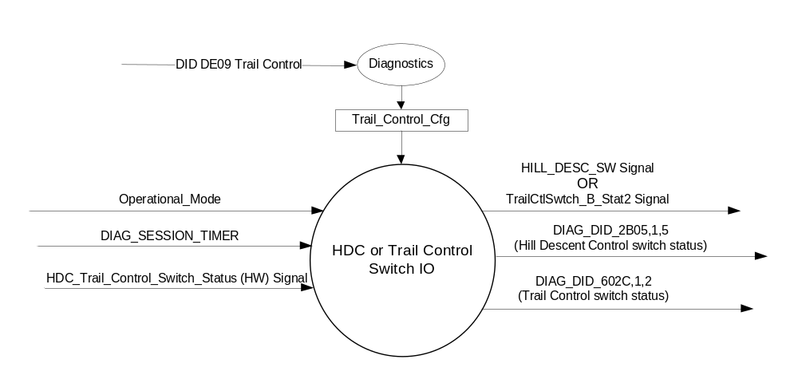

Inputs

      - INTERNAL:
            - DIAG_SESSION_TIMER
            - Operational_Mode
            - Trail_Control_Cfg - based on Trail Control parameter of DID DE09 indicating if the Trail Control feature is Enabled (0x1) or Disabled (0x0)
      - HDC_Switch_Status (HW) Signal:
1. To be sensed by a micro A/D input port or Digital port
2. Sensing circuit to sink a minimum current of 7 mAmps at 13.25 Volts thru the HDC switch.
3. To have 0 to 50 ohm input under all operating voltage conditions to be closed, which relates to a Press of the HDC Switch.
4. HDC switch will be closed to ground when pressed.

HDC or Trail Control  Switch Condition | HDC or Trail Control  Switch Logic | HDC or Trail Control  Switch Input | Debounce | HDC_Trail_Ctrl_Switch_Status
Not Pressed | Open | >100k ohms ⁽¹⁾ | 5 samples in a row @10 ms  or 6 samples in a row @8 ms | 0X1 (Not Pressed)
Pressed | Closed | =< 50 ohms | 5 samples in a row @10 ms  or 6 samples in a row @8 ms | 0X0 (Pressed)
- 100k ohms to meet ELCOMP RQT-191001-009863 (EC-0015)

Outputs
- DIAG_DID_2B05,1,5 (Hill Descent Control switch status)
- DIAG_DID_602C,1,2 (Trail Control switch status)
- Mux signals on the CAN network

- HILL_DESC_SW Signal
Signal Name | Size  (bits) | Detail | Units | Res. | Offset | State  Encoded | Min. | Max.
HILL_DESC_SW | 1 |  | SED | 1 | 0 |  | 0  (0x0) | 1 (0x1)
 |  | Off |  |  |  | 0x0
 |  | On |  |  |  | 0x1

- TrailCtlSwtch_B_Stat2 Signal
Signal Name | Size  (bits) | Detail | Units | Res. | Offset | State  Encoded | Min. | Max.
TrailCtlSwtch_B_Stat2 | 1 |  | SED | 1 | 0 |  | 0  (0x0) | 1 (0x1)
 |  | Not_Pressed |  |  |  | 0x0
 |  | Pressed |  |  |  | 0x1

Function/Performance

Operational Modes

Mode | Differentiating Vehicle Conditions
Sleep Mode | No sensing of Switch
Limited Mode | No sensing of Switch
Normal Mode | Sensing of Switch
Crank Mode | Sensing of Switch

Voltage Levels

Refer to the Cluster Features table located in the Operational Modes and Voltage Range Strategies Section in this SPSS

Human-Machine Interface

Visual

Indicator Graphics / Display Format
None

Indicator Color Coordinates

N/A

Indicator Characteristics

N/A

Audio

None.

System Accuracy

The output of the state matrix, reference 1.3.5.1 Subsystem Algorithm Flowchart/ State Diagram, shall occur
within 100msec of a state change.

Operation: Performance and Functional

Subsystem Algorithm Flowchart / State Diagram

Figure 1: Trail Control Feature Diagnostic Configuration Flowchart

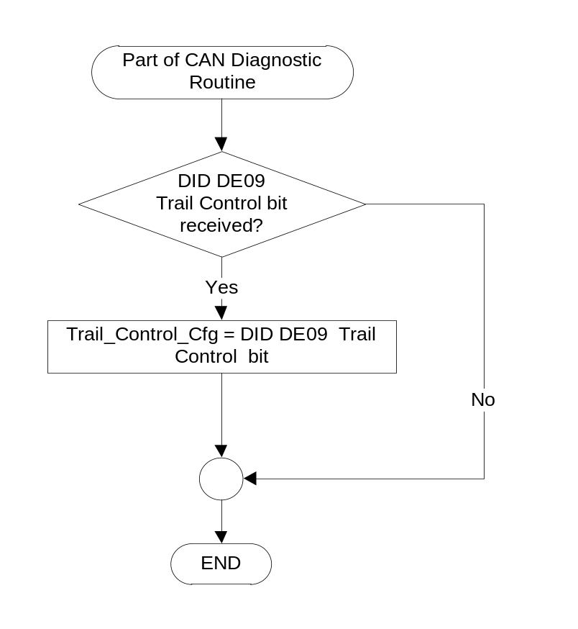

- State Matrix for HDC or Trail Control Switch IO
Operational  _Mode | Trail_Control  _Cfg | HDC_Trail_Ctrl_  Switch_Status | HILL_DESC_SW Signal | TrailCtlSwtch  _B_Stat2  Signal | DIAG_DID_2B05,1,5  (Hill Descent Control  switch status) | DIAG_DID_602C,1,2  (Trail Control  switch status)
Normal  or  Crank | Disabled  (0x0) | 0x0 (Pressed)  / GND | 0x1 (On) | 0x0 (Not_Pressed) | 0x1 (Active) | 0x0 (Inactive)
Normal  or  Crank | Disabled  (0x0) | 0x1 (Not Pressed)  / OPEN | 0x0 (Off) | 0x0 (Not_Pressed) | 0x0 (Inactive) | 0x0 (Inactive)
Normal  or  Crank | Enabled  (0x1) | 0x0 (Pressed)  / GND | 0x0 (Off) | 0x1 (Pressed) | 0x0 (Inactive) | 0x1 (Active)
Normal  or  Crank | Enabled  (0x1) | 0x1 (Not Pressed)  / OPEN | 0x0 (Off) | 0x0 (Not_Pressed) | 0x0 (Inactive) | 0x0 (Inactive)
All other cases |  |  | 0x0 (Off) | 0x0 (Not_Pressed) | 0x0 (Inactive) | 0x0 (Inactive)

Operation Description (supports algorithm flowchart /state diagram)

- The Trail Control and Hill Descent features are mutually exclusive, thus use the same hardwired input to process the switch press status.
- When Trail_Control_Cfg = Enabled (0x1), the vehicle is configured to support the Trail Control feature.
- When Trail_Control_Cfg = Disabled (0x0), the vehicle is configured to support the Hill Descent feature.
- On clusters that support Hill Descent only, the Trail_Control_Cfg should always be set to Disabled (0x0).

Function Safety Classification (EMC)

B

Memory Storage

Parameter Name | Description | Value at  Battery Connect | Value at  Module Wake-up
HDC_Trail_Ctrl_Switch_Status | Indicates the state of the HW Switch input | Not Pressed (0x1) | Not Pressed (0x1)
HILL_DESC_SW CAN signal | CAN signal output that provides status of Hill Descent switch | Off (0x0) | Off (0x0)
TrailCtlSwtch_B_Stat2 signal | CAN signal output that provide status of Trail Control switch | Not_Pressed (0x0) | Not_Pressed (0x0)
DIAG_DID_2B05,1,5 (Hill Descent Control switch status) | Hill Descent Control, byte 1, bit 5 | Inactive (0x0) | Inactive (0x0)
DIAG_DID_602C,1,2 (Trail Control switch status) | Trail Control Switch Status, byte 1, bit 2 | Inactive (0x0) | Inactive (0x0)
Trail_Control_Cfg | Internal flag used to indicate if Trail Control feature is present in the vehicle | Use Stored Value | Use Stored Value
Operational_Mode | 4 state indicator for cluster operational mode | Limited | Limited, Normal or Crank

Parameter Name | Description | Value at  Battery Connect | Value at  Module Wake-up
DIAG_SESSION_TIMER | Timer used to time-out a diagnostic session | Inactive | Inactive

Prove Out
No

Reconfigurable Telltale
No.

Message Center Msg
No.

Error Handling

Missing Message Strategy

None

Diagnostics

Self Test

None

Engineering Test Mode

Reference section “Dealer / Engineering Test Mode (ETM)”.

Part II Performance

DID $DEXX:
Block  Num | Block Description | Byte(s) | Bits | State: Description | "0" | "1" | Default | Comment
PACKETED BLOCKS
$xx | Option Content (B&A) | * | * | Trail Control | Disabled | Enabled | Disabled | Parameter allows Trail Control HW input to be broadcast over CAN. Enable if Trail Control feature is present on the vehicle and Trail Control Switch is hardwired to the cluster. Also see note below
 | *Byte and bit location to be identified in Part II Specification for this cluster

Note: The config bit should be set to Disabled (0) on clusters that support Hill Descent as a standalone feature only

or if Trail Control feature is not present on the vehicle.

Supported Diagnostic DIDs (Service $22)
Number | DID / CommonID Name | DID Type
2B05 | DIAG_DID_2B05,1,5 (Hill Descent Control switch status) | Bit Mapped
602C | DIAG_DID_602C,1,2 (Trail Control switch status) | Bit Mapped

Supported Diagnostic Trouble Codes (DTCs)
DTC | Description
None

Reference Specification

IS-0052 OPERATING VOLTAGES - FUNCTIONAL/PERFORMANCE
IS-0069 FUNCTIONAL IMPORTANCE CLASS

03-0661 PLACEMENT: CONTROL AND DISPLAY LOCATIONS
03-0662 PLACEMENT: LOGICAL GROUPING FUNCTION AND USAGE
03-0664 PLACEMENT: DOWN VISION TO COMPONENTS WITH HIGH VISUAL DEMAND
03-0665 PLACEMENT: EXPECTED LOCATIONS OF CONTROLS AND DISPLAYS VDS
03-0670 INTERIOR VISIBILITY
03-0671 INTERIOR VISIBILITY: REFLECTIONS FROM COMPONENTS & SURFACES
03-0672 INTERIOR VISIBILITY: REFLECTIONS IN DISPLAYS
03-0673 INTERIOR VISIBILITY: VISUAL OBSCURATIONS
03-0674 INTERIOR VISIBILITY: ILLUMINATION CONTROLS / DISPLAYS
03-0675 INTERIOR VISIBILITY: VEILING GLARE
03-0677 INTERIOR VISIBILITY: SUNLIGHT WASHOUT
03-0681 IDENTIFICATION: CHARACTER AND SYMBOL SIZE
03-0682 IDENTIFICATION: LEGIBILITY
03-0685 IDENTIFICATION: SYMBOLS, ABBREV FOR CONTROL
03-0721 LOGIC OF OPERATION: OPERATIONAL STEREOTYPES
03-0722 LOGIC OF OPERATION: INTERPRETATION
03-0723 LOGIC OF OPERATION: USE OF SYSTEMS WITH VISUAL DISPLAYS
EC-0128 SWITCH CONTACT RESISTANCE

Revision History

SPSS Module Revision History

Revision Level | Name | Change Description | Date
1.0 | V.Patel | Initial Release  Leveraged from “HDC_Switch_IO CGEA – CGEA1.3 v1.1” STSS. | 1/31/2017

